DAY29_Student Marks Analyzer (Dictionary)
Problem Statement
You are given student marks in different subjects. Use a dictionary to:
- Store student data
  - Calculate: Total marks
  - Average marks
  - Find: Top scorer
  - Failed students (marks < 40 in any subject)

Input Example
students = {
"Asha": {"Math": 78, "Science": 85, "English": 67},
"Ravi": {"Math": 35, "Science": 40, "English": 50}, "John": {"Math": 90, "Science": 92, "English": 88}
}
Tasks
- Calculate total & average for each student
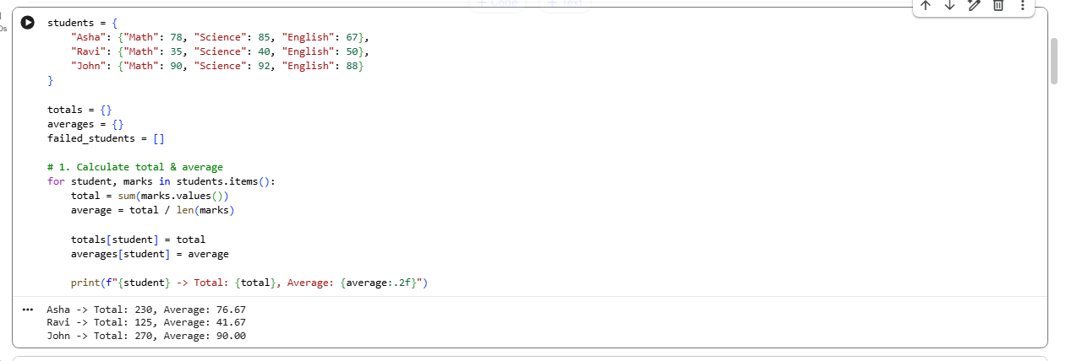

- Identify top scorer
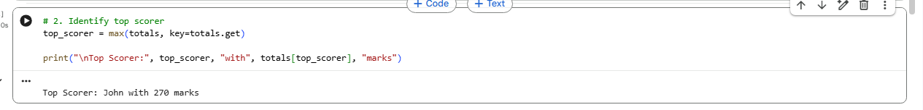

- Find students who failed in any subject
